DB OPERATIONS ENTITY FRAMEWORK

User

CREATE

READ

UPDATE

DELETE

**OPERATIONS(CRUD)**

DELETE CMD

UPDATE CMD

SELECT CMD

INSERT CMD

SAVE

CHANGES

SAVE

CHANGES

L2E

QUERY

SAVE

CHANGES

C

O

N

T

E

X

T

**Project properties to set which class it should run:**

**CRUD_Ops.cs**

(MAKE SURE MAIN IS IN THIS CLASS AND NOT IN PROGRAM.CS SO THAT U CAN RUN THIS AS STARTUP PROGRAM)

using System;

using System.Collections.Generic;

using System.Linq;

using System.Text;

using System.Threading.Tasks;

namespace DatabaseFirstConsole

{

class CRUD_Ops

{

static void Main(string[] args)

{

//first create object of dbcontext class

MyDbEntities db = new MyDbEntities();

DEPTLOC deptob = new DEPTLOC();

int ch, id;

do

{

Console.WriteLine("1 INSERT RECORD");

Console.WriteLine("2 DISPLAY RECORD");

Console.WriteLine("3 UPDATE RECORD");

Console.WriteLine("4 DELETE RECORD");

Console.WriteLine("5 EXIT");

Console.WriteLine("WHATS YOUR CHOICE = ");

ch = Convert.ToInt32(Console.ReadLine());

switch(ch)

{

case 1:

Console.Write("Enter areaId=");

deptob.AREAID = Convert.ToInt32(Console.ReadLine());

Console.Write("Enter areaName=");

deptob.AREANAME = Console.ReadLine();

Console.Write("Enter cityId=");

deptob.CITYID = Convert.ToInt32(Console.ReadLine());

Console.Write("Enter phoneNum=");

deptob.PHONE = Convert.ToInt64(Console.ReadLine());

//as mentioned earlier the object has to be added to dbcontext instance

db.DEPTLOCs.Add(deptob);

//inorder to save the changes

db.SaveChanges();

break;

case 2:

foreach(DEPTLOC d in db.DEPTLOCs)

{

Console.WriteLine("{0}\t{1}\t{2}\t{3}\t{4}\t",d.AREAID,d.AREANAME,d.CITYID,d.PHONE,d.CITy.CITYNAME);

}

break;

case 3:

Console.Write("Enter id to update ");

id = Convert.ToInt32(Console.ReadLine());

deptob =db.DEPTLOCs.Find(id);

if(deptob == null)

Console.WriteLine("invalid area id ");

else

{

Console.Write("Enter areaName=");

deptob.AREANAME = Console.ReadLine();

Console.Write("Enter cityId=");

deptob.CITYID = Convert.ToInt32(Console.ReadLine());

Console.Write("Enter phoneNum=");

deptob.PHONE = Convert.ToInt64(Console.ReadLine());

db.SaveChanges();

}

break;

case 4:

Console.Write("Enter id to delete ");

id = Convert.ToInt32(Console.ReadLine());

deptob = db.DEPTLOCs.Find(id);

if (deptob == null)

Console.WriteLine("invalid area id ");

else

{

db.DEPTLOCs.Remove(deptob);

db.SaveChanges();

}

break;

case 5:

break;

default:

break;

}

} while (ch != 5);

}

}

}

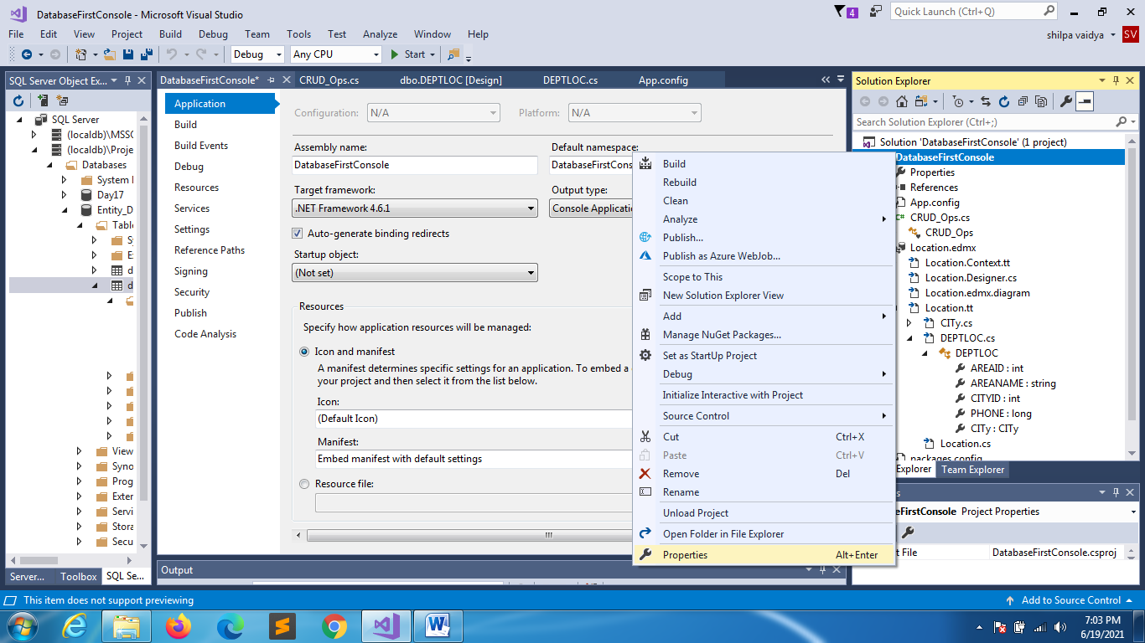

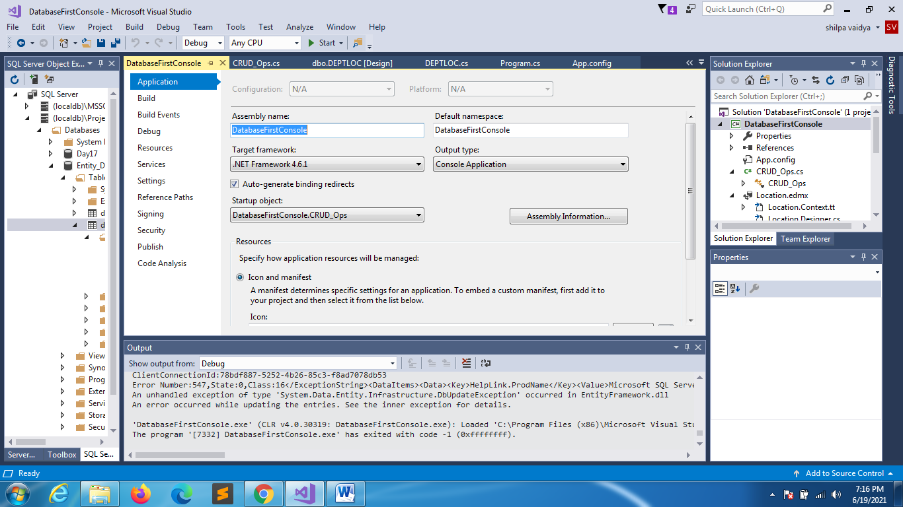

**KEEP CITIES TABLE POPULATED**

